Software Design Document

<Victoria State Accident>

Eddie Thompson s5282264

Fletcher Bradley s5292215

Kei Giliam s5270448

Assignment Groups 130

Table of Contents

1.0 System Vision 3

1.1 Problem Background 3

1.2 System Overview 3

1.3 Potential Benefits 3

2.0 Requirements 4

2.1 User Requirements 4

2.2 Software Requirements 4

2.3 Use Cases 4

3.0 System Components and Software Design 5

3.1 System Components 5

3.2 Software Design 5

4.0 User Interface Design 6

# System Vision

## Problem Background

The dataset we have chosen is the Victorian state accident dataset. There are far too many accidents on our roads and we feel the need to develop an application which will let data scientists, lawmakers and other researchers interface with the aforementioned dataset. The dataset lists all fatal and injury accidents in Victoria from 2015 to 2020, as well as displaying various other factors such as time, locations, the involvement of alcohol and more.

## System Overview

The features we intend to fit into our application include:

* The ability for the user to enter a period and have the application show all of the accidents from the dataset in between the specific period
* The ability for the user to enter a period and have the application produce a chart that shows the number of average accidents per hour of the day.
* The ability for the user to enter a period and a keyword and have the program show all of the accidents from the dataset involving the aforementioned keyword.
* The ability for the user to view the impacts that alcohol has had on the data
* The ability for the user to enter a period and a specific day of the week and have the program show all of the accidents taking place on the specific day of the week.

## Potential Benefits

Our software will give the ability to lawmakers and researchers to closely examine the trends that occur with road traffic accidents and will empower them to plan accordingly.

We believe our analysis software could help researchers decide on policies to prevent future road accidents by streamlining the time consuming process of sorting raw data by having the program itself do it automatically depending on user input.

The program could also help researchers identify specific trends that occur within the data via the automated chart generation feature we are planning to implement.

We fully believe that this software could potentially dramatically contribute to the lowering of traffic accident rates in Australia.

# Requirements

## User Requirements

We believe that our developed program would be best utilized by the Australian Government, specifically the Office of Road Safety for the purposes of analyzing large amounts of road accident data and to use their findings to inform their efforts going forward. For this purpose, here are some of the user requirements that will be needed to implement.

* The user must be able to enter a start date and an end date and get the accidents between those dates back.
* The user must be able to make the program generate a chart showing accidents on specific hours of days in the previously user selected period.
* The user must be able to search the accident database for a specific keyword
* The user should be able to view a specific section documenting alcohols impact on the data

The user should be able to choose a day of the week inside their period for the software to focus on.

## Software Requirements

The software will be required to perform the following actions to be considered feature complete:

* The software shall contain the complete dataset of road accidents
* The software shall be capable of displaying the dataset in a human readable way
* The software shall be simple to use and appealing to the eyes of its users
* The software shall take several user inputs and provide different outputted data depending on the input

## Use Cases & Use Case Diagrams

There are several potential use cases for the system we are developing. Here are a few potential use cases.

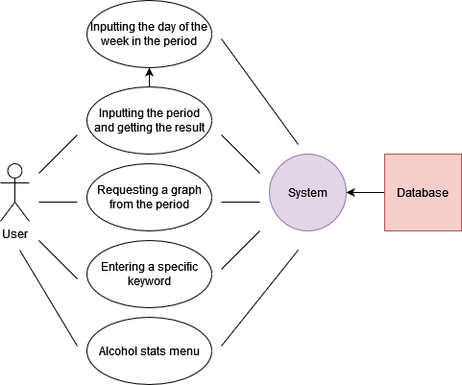

|  |  |
| --- | --- |
| **Use Case ID** | 1 |
| **Use Case Name** | Inputting Period |
| **Actors** | User |
| **Description** | The user inputs the period they wish to see results between. |
| **Flow of events** | 1. The user will enter the system. 2. The user will enter a start date in the start date search box 3. The user will enter a end date in the end date search box 4. The system will present the user with the requested results |

|  |  |
| --- | --- |
| **Use Case ID** | 2 |
| **Use Case Name** | Inputting specific day of the week |
| **Actors** | User |
| **Description** | After inputting the period, the user inputs a day of the week to narrow down their search. |
| **Flow of events** | 1. The user will have completed use case ID 1. 2. The user will click the specific day drop down menu 3. The user will click on the day they want 4. The user will click confirm 5. The system will present the user with the narrowed down results |

|  |  |
| --- | --- |
| **Use Case ID** | 3 |
| **Use Case Name** | Requesting a graph from the period |
| **Actors** | User |
| **Description** | The user requests a graph based on the period they have already selected. |
| **Flow of events** | 1. The user will have completed use case ID 1 2. The user will click GENERATE GRAPH button 3. The system will present the user with the generated graph |

|  |  |
| --- | --- |
| **Use Case ID** | 4 |
| **Use Case Name** | Entering a specific keyword |
| **Actors** | User |
| **Description** | The user enters a specific search keyword |
| **Flow of events** | 1. The user will enter a keyword in the keyword search 2. The user will click search 3. The system will provide narrowed down search results based off of the keyword |

|  |  |
| --- | --- |
| **Use Case ID** | 5 |
| **Use Case Name** | Accessing the Alcohol Stats menu |
| **Actors** | User |
| **Description** | The user views the alcohol statistics menu |
| **Flow of events** | 1. The user will be in the system already 2. The user will click the alcohol stats button 3. The system will bring up the alcohol stats screen |

# Software Design and System Components

## Software Design

The following diagram is a flowchart showing the various uses of the system:

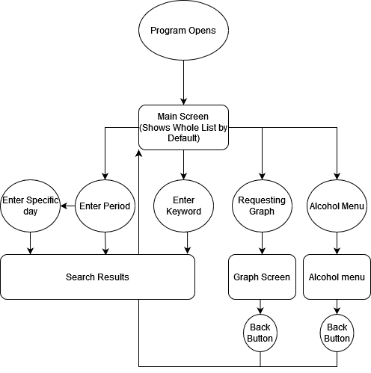

## System Components

### Functions

|  |  |
| --- | --- |
| Function Name | Load Data |
| Function Description | Load the data from the Victorian road accidents dataset |
| Function Input Parameters, data types and use | Dataset, dataset, loads dataset to be displayed |
| Function side effects? | None? |
| Function return value description | The data contained inside the dataset file |

|  |  |
| --- | --- |
| Function Name | Display Data |
| Function Description | Display the data based on user inputs |
| Function Input Parameters, data types and use | Loaded Dataset + user input parameters, Arrays, displays the dataset based on user search queries |
| Function side effects? | None? |
| Function return value description | The data to be displayed |

|  |  |
| --- | --- |
| Function Name | Main class function |
| Function Description | Stores and manages crucial system operations |
| Function Input Parameters, data types and use |  |
| Function side effects? | None? |
| Function return value description |  |

### Data Structures / Data Sources

Array

* Used from the dataset
* Used to store information from the dataset.
* Data = [“Days”, “Accidents”, “Causes”]
* loadData()

### Detailed Design

1. Input starting date and finish date = selected accident

Print selected accident

1. Input starting date and finish date = selected accident

Selected day = true

Print average day

1. Input keyword

Print selected accident

1. If alcohol related = true

Print

1. If day = monday

Print

Elif day = tuesday

Print

… (print each day of week)

# User Interface Design

In the initial interface design, this project is using wxFormBuilder. For designing our interfaces we also used the website draw.io to create the wireframe designs and diagrams used in the below sections.

## Structural Design

Our system will be navigable by mostly a simple menu bar up the top like many other programs. The information extracted from the dataset will be displayed in a table like fashion with a top table bar that labels each column that does not scroll with the rest of the table. There will be a searching bar where users can search for specific dates to see data that occurred on that date.

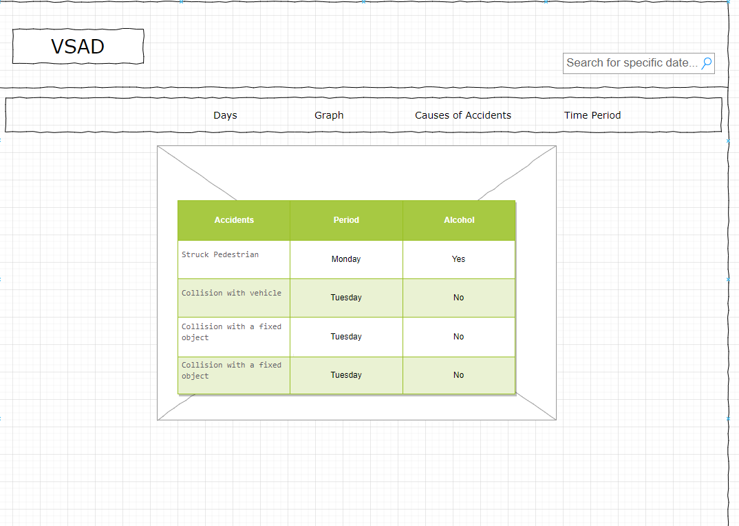

## Visual Design

Figures of bellow are our visual design (first version).

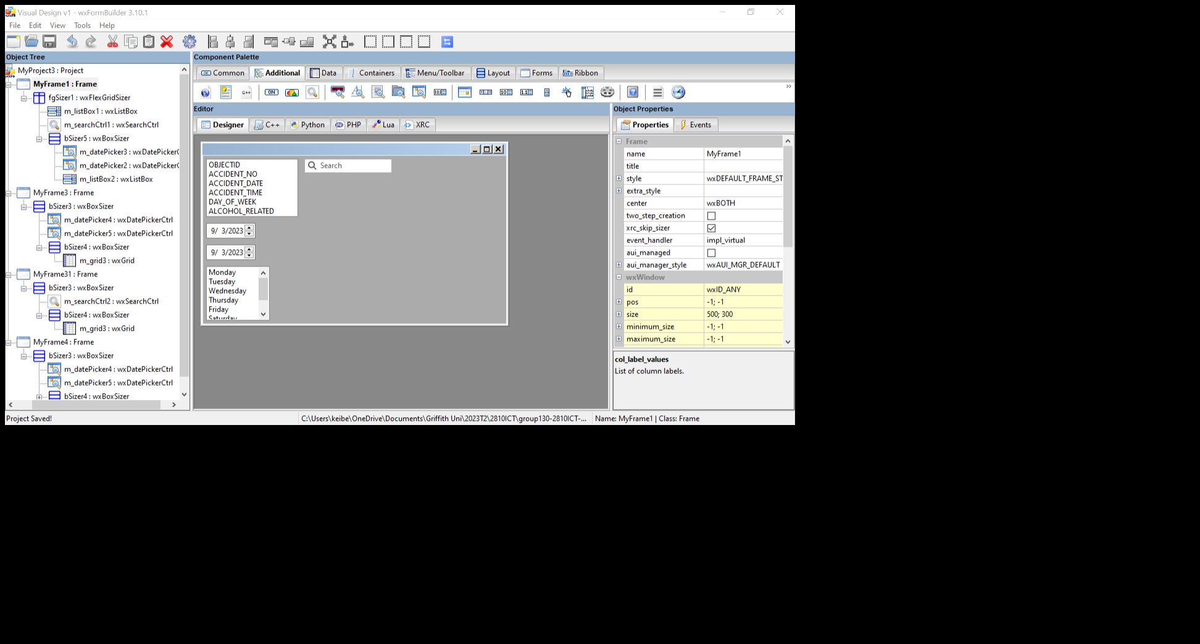

Figure 1: Home page. User can choose options of searching displayed data by multiple options.

* Select by columns
* Select by starting and finishing dates
* Select by day of weeks
* Search by keyword

